PETER SCHATZMANN – Co-Founder & Vice President

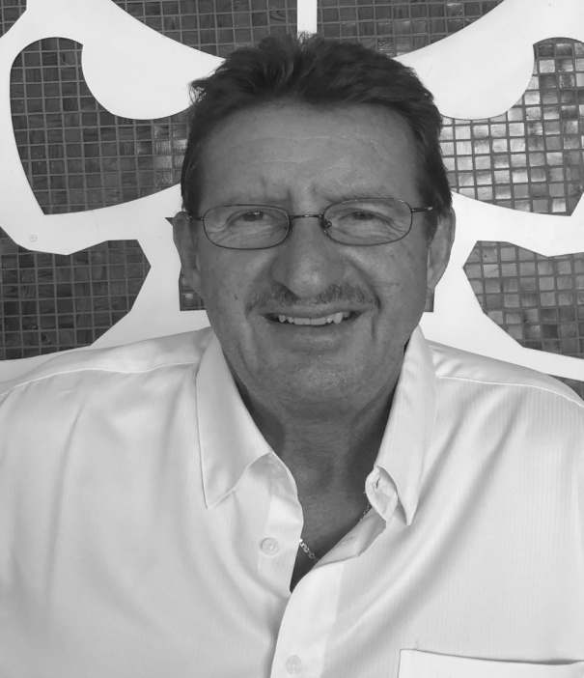

*“****Step inside and let us hand you the key to capitalize from our expertise with decades of experience****”*

Personal:

Swiss / Australian citizenships

Swiss educated: Chef Apprenticeship, Management certification courses with Hyatt Intl. and MOHG

Positions held: Executive Chef, Corporate chef/F&B, VP Talent Acquisition, ESI President Thailand office, Founder & Owner PIHC

Core Strengths:

* Leadership, training- communications and people management skills
* Task master in planning, project & concept development, orchestrating of large scale events
* Implement practical systems & procedures and adhering to agreed deadlines
* Numerous Global Hotel and Restaurant openings in various capacities.
* Direct owner relations & reporting; balancing relations between owners and operators.
* Teambuilding, training & development; specifically in Culinary/F&B
* Creative culinary innovations, menu & recipe development, quality & cost control, health & hygiene standards
* Passionate about the training & supporting of upcoming talent in the Culinary and Hospitality Field Worldwide.
* Extremely detail oriented with a contemporary approach to change and quality lifestyle experience

Languages:

German, English fluent, French, Italian conversational

Destinations of previous work deployments:

Switzerland, Africa, Middle East, China (Macau & Hong Kong), South Pacific, Australia, South Korea, India, United States, South East Asia (Philippines,Thailand)